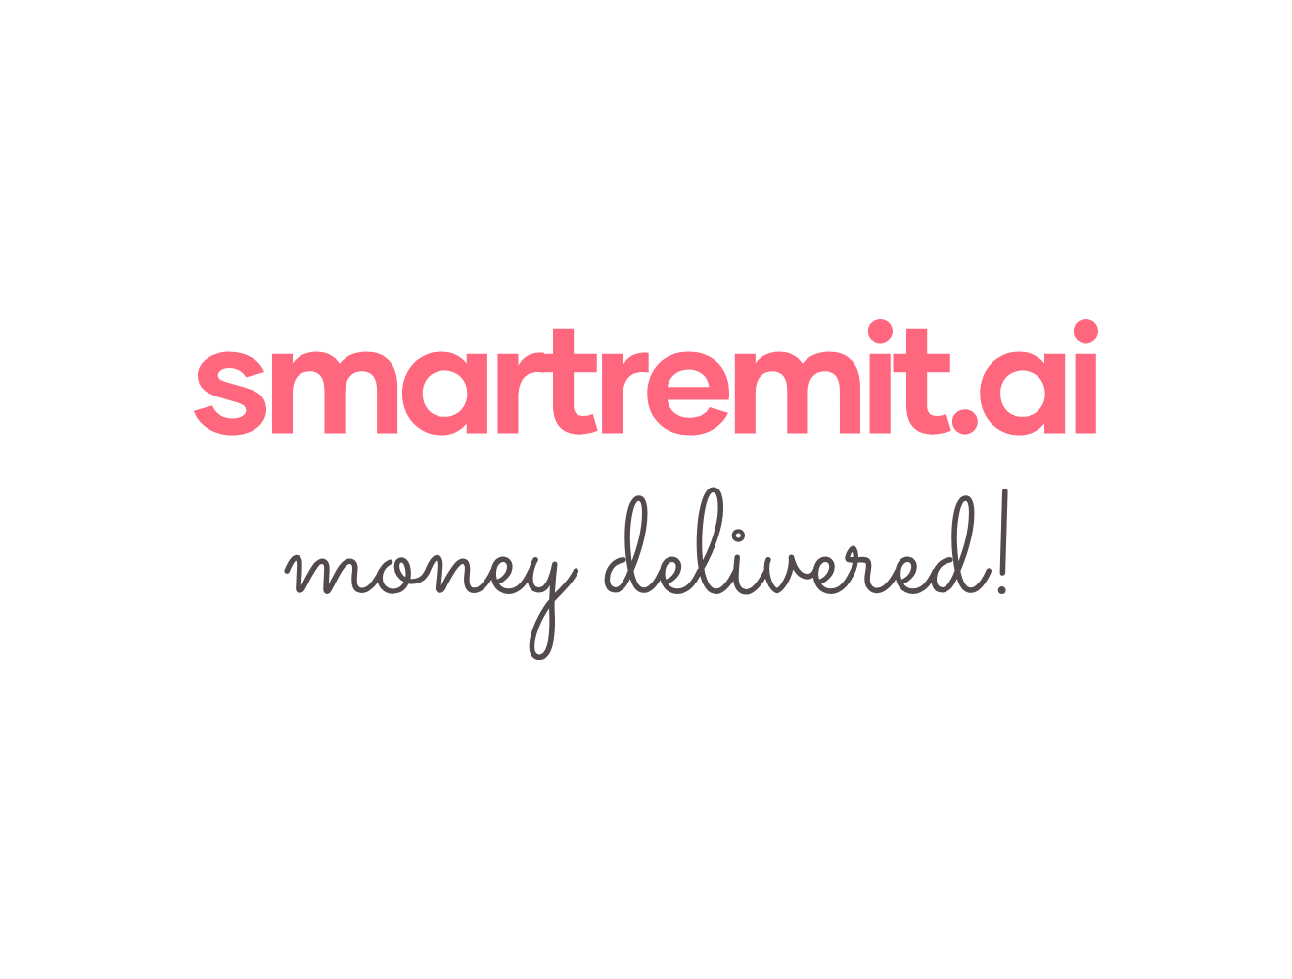SmartRemit Customer Onboarding Register

1. Customer Master Register.
No. | Customer Name | Customer Type | Registered Address | Primary Contact | Email / Phone | Countries Covered | Status
1
2
3
4
5
6
7

2. Corridors and Currency Details
No. | Sending Country | Collection Currency | Receiving Country | Payout Currency | Payout Methods | Supported Corridor Status
1 | United States | USD | India | INR | Bank account / UPI / IMPS
2 | United Kingdom | GBP | India | INR | Bank account / UPI / IMPS
3 | United Arab Emirates | AED | India | INR | Bank account / UPI / IMPS
4 | Australia | AUD | India | INR | Bank account / UPI / IMPS
5 | Singapore | SGD | India | INR | Bank account / UPI / IMPS
6 | Canada | CAD | India | INR | Bank account / UPI / IMPS
7 | New Zealand | NZD | India | INR | Bank account / UPI / IMPS

3. Collection Bank Account Details
Country | Currency | Bank Name | Account Name | Account No. / IBAN | Routing / Sort / BSB / SWIFT | Settlement Cycle | Notes
United States | USD
United Kingdom | GBP
United Arab Emirates | AED
Australia | AUD
Singapore | SGD
Canada | CAD
New Zealand | NZD

4. Onboarding Documents Required for Activation
No. | Document / Item | Details to Collect | Required For | Status
1 | Company profile | Legal name, registered address, website, business type, operating countries | All customers
2 | Certificate of incorporation / trade license | Proof of legal registration and right to operate | All customers
3 | Remittance / exchange / banking license | Regulatory approval to provide remittance, banking, or exchange services | Banks, remittance and exchange companies
4 | AML / compliance policy | Internal AML, sanctions screening, transaction monitoring and reporting process | All financial customers
5 | KYC policy | Customer onboarding, identity verification and document collection rules | All financial customers
6 | Authorized signatory details | Name, role, email, phone and ID proof if required | Contract signing
7 | Bank account confirmation | Collection account details, settlement account details and currency support | Finance setup
8 | API documentation | Sandbox access, production access, authentication method and webhook details | Technical integration
9 | Commercial proposal | Setup fees, transaction fees, FX margin, payout fee and refund charges | Commercial review
10 | Support and escalation contacts | Local support contacts for all countries in scope | Operations

5. Terms and Conditions to Confirm
No. | Area | Details to Confirm
1 | Commercial Terms | Setup fee, monthly fee, transaction fee, payout fee, refund fee, and FX margin.
2 | Settlement Terms | How and when funds are collected, settled, reconciled and refunded.
3 | Transaction Limits | Minimum and maximum transfer amount per transaction, per day and per month.
4 | Delivery Time | Expected delivery time for each corridor and payout method.
5 | Compliance Responsibility | Who performs KYC, AML screening, sanctions checks and transaction monitoring.
6 | Data Security | How customer data, account data, API keys, and transaction records are protected.
7 | Refund and Cancellation Rules | When transfers can be cancelled, reversed, refunded or held for review.
8 | Dispute Handling | Process for failed payouts, incorrect beneficiary details, stuck transfers and customer complaints.
9 | Support SLA | Response time and escalation process for each country.

Rohan Yedla please create separate documents for each of the above, we may have to provide links to these for Customers when they initiate transfers or provide a weblink, you can use any of the partner documents for now, we will review and update later

6. Delivery Times, Fees and Transfer Limits
Corridor | Send Currency | Receive Currency | Delivery Method | Expected Delivery Time | Transfer Limits | Customer Fee | Partner Fee / FX Margin
US to India | USD | INR
UK to India | GBP | INR
UAE to India | AED | INR
Australia to India | AUD | INR
Singapore to India | SGD | INR
Canada to India | CAD | INR
New Zealand to India | NZD | INR

7. Customer Support and Local Contacts
Country | Support Team / Contact Person | Email | Phone | Support Hours | Escalation Contact | SLA
United States
United Kingdom
United Arab Emirates
Australia
Singapore
Canada
New Zealand
India payout support

8. APIs, Keys and Unique Reference Numbers
API Area | Partner / API Name | API KEY  (Provided by partner) | Purpose | Keys / Unique IDs to Capture | Sandbox Status | Production Status
Messaging / WhatsApp |  |  | WhatsApp messages, alerts and status notifications | message_id, conversation_id, waba_id, phone_number_id, webhook_event_id
KYC / Compliance |  |  | Identity verification, sanctions screening and risk review | kyc_case_id, verification_id, screening_id, risk_case_id
Funding / Collection |  |  | Collect funds from sender through bank account, card or local payment method | funding_source_id, collection_account_id, payment_reference_id
FX / Quote |  |  | Create exchange rate quotes and lock rates for confirmation | quote_id, rate_id, quote_expiry_time, customer_transaction_id
Payout to India |  |  | Send INR to recipient bank account, UPI or IMPS | payout_id, beneficiary_id, UTR, bank_reference_no, payout_status
Reconciliation |  |  | Match collected funds, FX conversion and India payout | transaction_id, partner_reference_id, settlement_batch_id, reconciliation_id

9. Activation Checklist
No. | Checklist Item | Status
1 | Customer profile completed
2 | Registered address and contact details verified
3 | Corridors and currencies confirmed
4 | Collection bank account details received securely
5 | Required onboarding documents collected
6 | Commercial terms reviewed and agreed
7 | Terms and conditions reviewed
8 | API documentation and sandbox access received
9 | Test transactions completed successfully
10 | Support contacts and escalation process confirmed
11 | Compliance approval received
12 | Customer ready for production activation
13 | Customer Blocked(asked by partner)
14 | Limit Increase(based on 6 months of activity)
15 | Beneficiary blocked(due to OFAC)
16 | Smoke Test(initiate 1 small value transfer and confirm) before activation
17 | Cancellation process validation

